JUXTAPOSITION

This refers to the act of placing two things of contrasting effect close to, or next to one another, in order to compare them, or to highlight their differences.

Adam Moore

In this photograph, Adam Moore has chosen to use a viewpoint which juxtaposes the traffic sign with the religious statue.
The dramatic lighting adds to the sense that the sign is directing ‘lost souls’
TABLE EDGE
In traditional still life painting we often see the edge of the table running parallel to, and close to the bottom of the canvas. The objects on the table are often pushed very close to the edge.

Horizontal lines in art create a sense of calmness or serenity. They also work well with the juxtaposition of strong vertical elements.
The objects at the edge of the table create a spatial ambiguity or abstraction. They seem to come into the plane of the viewer.
The way that they are precariously balanced on the table’s edge is also often symbolic for the fragile nature of life.
DIAGONALS
An image with strong diagonals will communicate energy, dynamism, growth and direction.
Diagonals can also be used to suggest tension, anger and struggle.
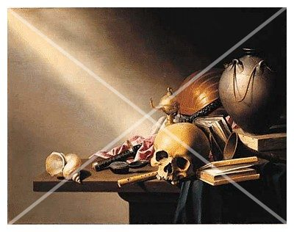

Including diagonals in still life compositions can also improve the impression of depth. By arranging your still life objects along diagonal lines you can artificially produce a feeling of distance.
A diagonal line leads the eye along it more than any other line. This can be extremely valuable for encouraging the viewer’s attention to move in certain directions.
RULE OF THIRDS
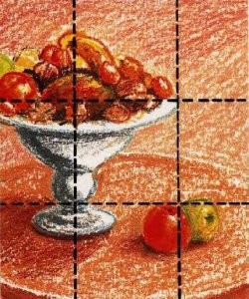
This is also known as the ‘golden ratio’ or the ‘golden section’. It involves placing an imaginary grid over the composition and arranging your points of interest on the intersecting lines.

For some reason, the points at which the lines intersect are where the eye finds it most satisfactory to view the main subject/s.
By arranging still life objects in this way the picture seems more balanced and harmonious.

PYRAMIDAL
Pyramidal (or triangular) compositions are very popular in still life for a number of reasons.
Firstly, they are very easy to construct. They are the most basic of geometric shapes (having the least number of sides).
Their shape lends compositions to being both dynamic (due to the diagonals), and stable (provided that one side is a level base).
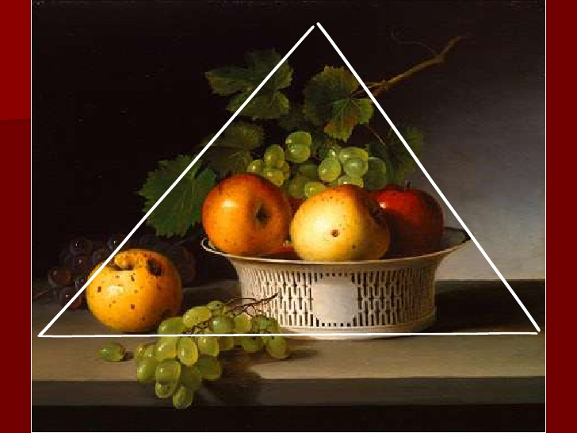

The sense of stability that comes from this composition comes from its structural association (ie. a pyramid).
By arranging 3 objects so that 2 form a base and the third an apex creates a stable form which is carried over into the image.
CENTRALISED COMPOSITION
A composition which is centralised is generally more symmetrical than asymmetrical. It has an overall equality of size and value and is usually divisible into equal halves.
It is apt to be a more passive design, spatially more static and aesthetically more decorative.
